Kino Lorber acquires U.S. and Canadian distribution rights for NATIONTIME by William Greaves, about the historic National Black Political Convention of 1972 which brought together major Black leaders and activists of the time.

October 23 release date in virtual cinemas through Kino Marquee

Original full-length version was miraculously found and restored in 4K by IndieCollect, supervised by Louise Greaves and funded by Jane Fonda and the Hollywood Foreign Press Association Trust

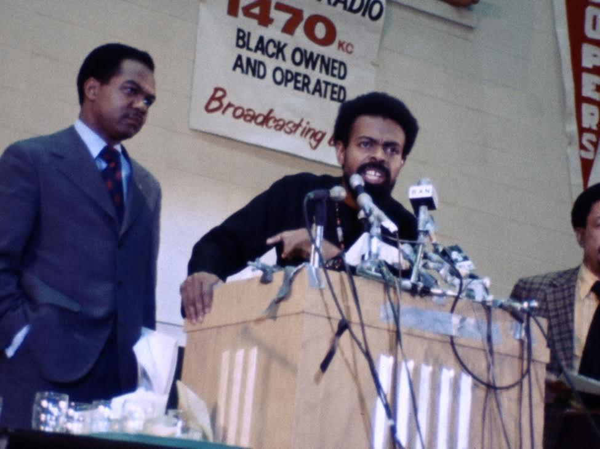

New York – September 28, 2020. Kino Lorber announces that it has acquired U.S. and Canadian distribution rights to William Greaves’ essential documentary, NATIONTIME, about the National Black Political Convention of 1972 held in Gary, Indiana. The film will be released in virtual cinemas through Kino Marquee starting October 23. This miraculous 4K version was restored by IndieCollect under the supervision of Louise Greaves, the director’s widow and filmmaking partner, with color correction by Oskar Miarka. Considered too radical for television broadcast at the time, it has since circulated only in a heavily edited 60-minute version. The new restoration, long thought lost and unearthed in a Pittsburgh warehouse in 2018, returns the film to its original 90-minute length and colorful visual quality 48 years after the convention took place.

The documentary presents a dynamic and powerful look at the Gary Convention which gathered over 10,000 Black politicians, activists, and artists from across the political spectrum, including more than 500 media representatives. The film is narrated by Sidney Poitier combined with poems recited by Harry Belafonte. Delegates included Black Panther co-founder Bobby Seale, Coretta Scott King, Pan-Africanist Artist and Activist Amiri Baraka, Dr. Betty Shabazz, PUSH founder Rev. Jesse Jackson, Fannie Lou Hamer and Queen Mother Moore, and elected officials Ron Dellums, Charles Diggs, Walter Fauntroy, Richard Hatcher, Carl McCall. Activists and entertainers Belafonte, Dick Gregory, Isaac Hayes and Richard Roundtree performed for the crowds over the three days.

Seale said at the Convention, "Revolution is about the right for the humanity of Black people in this country here and across the world to survive."

Amiri Baraka, along with Congressman Charles C. Diggs, Jr., and Mayor Richard Hatcher of Gary, set the convention in motion and served as Co-Chair. It was Baraka who suggested William Greaves to record the convention; he and his son David filmed over a span of three days with a tiny crew and no financing. William Greaves (1926-2014) was a pioneering Emmy Award-winning documentarian of black history, culture and politics, helming over 100 films including the notable avant-garde meta-documentary Symbiopsychotaxiplasm.

In August 2020, a coalition of Black organizations, inspired by the seminal 1972 event, organized the 2020 Black National Convention, an event that was hosted and live streamed by the Movement for Black Lives (M4BL).

Actor and activist Jane Fonda and the Hollywood Foreign Press Association Trust funded the restoration. Fonda has become an outspoken champion of the continued need to preserve our film heritage, stating recently, “Perhaps we ought to invest as much money in saving films as we do in making them.”

Nationtime was negotiated by Wendy Lidell, SVP of Kino Lorber and IndieCollect President Sandra Schulberg.

Richard Lorber, President and CEO of Kino Lorber said, "With the Black Lives Matter movement at the forefront and our country heading into the 2020 political conventions, we are proud to release the complete cut of Nationtime. We hope that the spirit and energy of the National Black Political Convention of 1972 will be a reminder of how much work still needs to be done to push for racial equality for all Black people in our country.”

Louise Greaves said, “A turning point in the struggle for self-determination and equal rights, the National Black Political Convention of 1972 adjourned without reaching consensus and some deemed it a failure. But the cry of ‘Nationtime’ reverberates as America continues to wrestle with its legacy of slavery. I know Bill would be absolutely thrilled that Nationtime is being released nationwide at this critical moment in our history.”

Nationtime will be rolled out in virtual cinemas starting October 23 and will later be available on KinoNow.com and home video.

Kino Lorber
With a library of over 4,000 titles, Kino Lorber Inc. has been a leader in independent art house distribution for 35 years, releasing 30 films per year theatrically under its Kino Lorber, Kino Repertory and Alive Mind Cinema banners, garnering seven Academy Award® nominations in nine years. In addition, the company brings over 350 titles yearly to the home entertainment and educational markets through physical and digital media releases. With an expanding family of distributed labels, Kino Lorber handles releases in ancillary media for Zeitgeist Films, Carlotta USA, Adopt Films, Greenwich Entertainment, Raro Video, and others, placing physical titles through all wholesale, retail, and direct to consumer channels, as well as direct digital distribution through over 40 OTT services including all major TVOD and SVOD platforms. In 2019, the company launched its new art house digital channel Kino Now which features over 1000 titles from the acclaimed Kino Lorber library. In response to the COVID-19 pandemic, the Kino Marquee initiative was launched in 2020 pioneering "virtual theatrical" releases of art house films with revenue shares that allows audiences to support almost 400 local independent theaters.

IndieCollect
Founded as the Laboratory for Icon & Idiom, Inc. in 1985, the non-profit organization has been doing business as IndieCollect since 2008. Its mission is to rescue, restore and reactivate important indie films so they remain discoverable and watchable today and in the future. With its Kinetta Archival Scanner and in-house team of colorists, IndieCollect has created acclaimed 4K digital restorations of more than 40 titles, including Cane River, In The Soup, Jazz on a Summer’s Day, Kaddish, Lineage, Nationtime, Seeing Red, Thank You and Goodnight, The Atomic Cafe, The Believer, The War at Home, Thousand Pieces of Gold, and George Romero’s long-unseen film, The Amusement Park. The organization also tracks down lost elements, helps archives to diversify their collections, facilitates the re-release of films so their makers can derive revenues therefrom, and does legacy planning. IndieCollect has been supported by Just Film / Ford Foundation, Weissman Family Foundation, Donald A. Pels Charitable Trust, Ira M. Resnick Foundation, Filmhaus Foundation, and major donors like Bill & Laurie Benenson, Stanley Buchthal, Jane Fonda, Beverly Grossman, Ann Hu, Jon Kamen, Lyda Kuth, Gerald Herman, Sybil Robson Orr, John Ptak and Catherine Wyler. DELL, NVIDIA and Blackmagic Design provide in-kind corporate support for the restorations.

William Greaves
Director, producer and writer William Greaves [1926-2014] began his career as a featured actor on Broadway and in motion pictures. His work behind the camera has earned him over 70 international film festival awards including an Emmy and four Emmy nominations. In 1980 he was inducted into the Black Filmmakers Hall of Fame, and in the same year he was the recipient of a special homage at the first Black American Independent Film Festival in Paris. In 1986, he received an Indy -- the special Life Achievement Award -- from the Association of Independent Video and Filmmakers. He has been honored by the National Black Theater and Film Festival with its first award for Lifelong Achievement in Film and for Contributions to Black Theater.

Greaves has produced and directed television, documentaries and feature films over the course of his career. For two years, he served as executive producer and co-host of the pioneering network television series BLACK JOURNAL, for which he was awarded an Emmy. His film, Ralph Bunche: An American Odyssey, a 2 hour documentary which aired prime-time on PBS, was shown in competition at Sundance and has won a Gold Award from two International Film Festivals. Among his other outstanding documentary films are FROM THESE ROOTS, an in-depth study of the Harlem Renaissance which has won over 20 film festival awards and has become a classic in African American history studies and IDA B. WELLS: A PASSION FOR JUSTICE, which has won 19 film festival awards and was nominated for a 1990 NAACP Image Award. Greaves also served as Executive Producer of Universal Picturesí BUSTIN’ LOOSE, starring Richard Pryor and Cicely Tyson, and produced, wrote and directed three feature films -- SYMBIOPSYCHOTAXIPLASM: TAKE ONE; THE MARIJUANA AFFAIR; and ALI, THE FIGHTER, starring Muhammad Ali and Joe Frazier. Retrospectives of William Greaves work have been held at the Museum of Modern Art and the Brooklyn Museum in New York.

A long-time member of The Actors Studio in New York, William Greaves was honored by the Studio in 1980 as a recipient of its first Dusa award, together with Studio members Robert DeNiro, Jane Fonda, Marlon Brando, Arthur Penn, Sally Field, Rod Steiger, Al Pacino, Shelley Winters, Dustin Hoffman, Estelle Parsons, and Ellen Burstyn, among others. From 1969 to 1982, he taught acting for film and television for the late Lee Strasberg at the Strasberg Theatre Institute in New York, and on occasion, substituted for Mr. Strasberg as moderator of the Actors Studio sessions.

MEDIA CONTACTS:
Kino Lorber
David Ninh - dninh@kinolorber.com

Human Impact Solutions
Tracey Wood Mendelsohn - tracey@humanimpactsolutions.com
Janet Dickerson - janet@humanimpactsolutions.com

